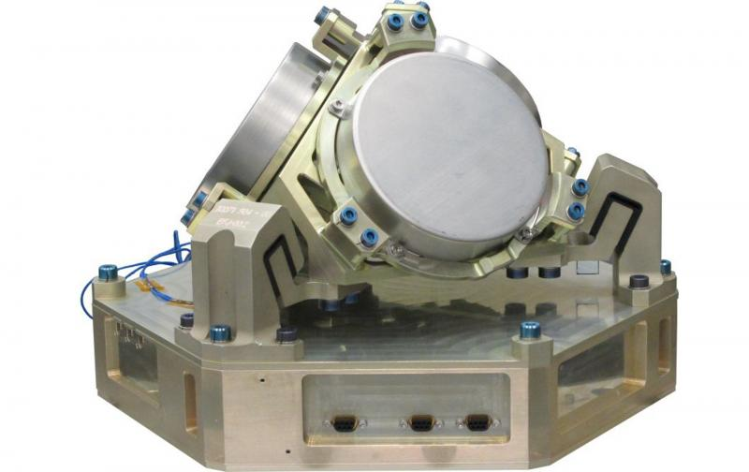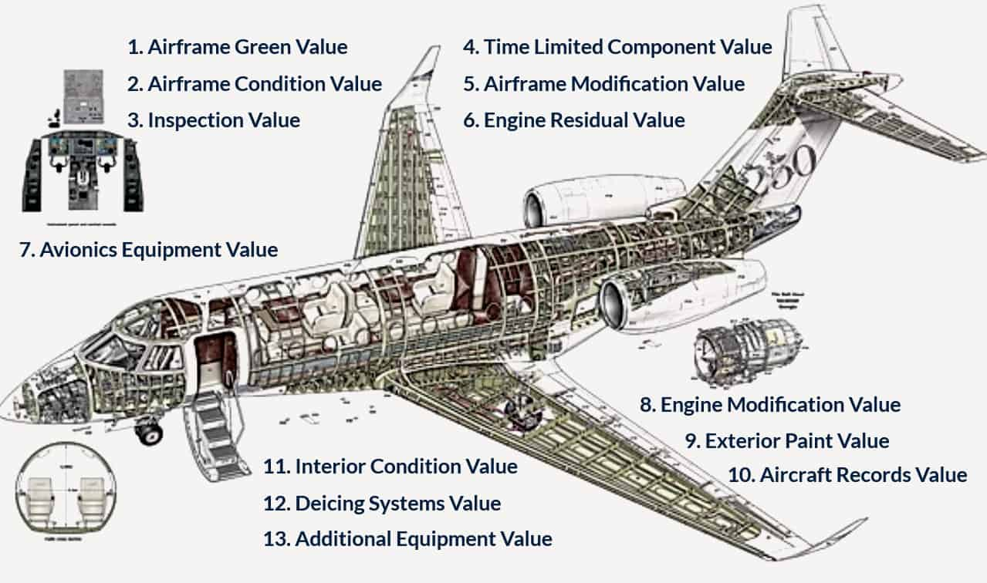

* + Aircraft Appraisers
  + Aircraft Valuation and Consultancy
  + Aviation / Industrial Equipment
  + Aviation / Industrial Tools
  + Aviation / Industrial Components / Spare Parts / Item / Material
  + General / Specialised equipment / components / material / items
  + Customised solutions for industry including aerospace / avionics
  + Satellite Components
  + Indenters
  + General Order Suppliers
  + Importers / Exporters

[info@soanairland.com](mailto:info@soanairland.com)

+923005345222